QUESTION 1 Notes

Question 1 A
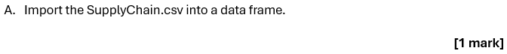
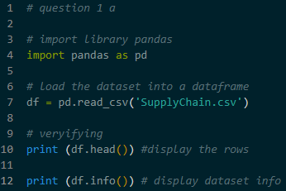
- Importing data using pd.read_csv to open the file
- This moves the data from a static file into the computer’s memory so it can be change it

Question 1 B
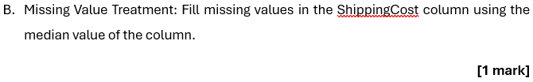
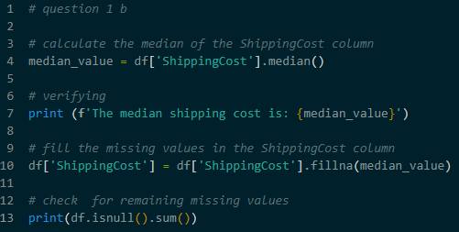
- Columns often have empty cells (called NaN). If left empty, these can cause errors in math calculations
- Action – Finding the median of the ShippingCost column. Use .fillna() to put that number into the empty cells
- The median is used because It represents the center of the data without being affected by very high or very low numbers

Question 1 C
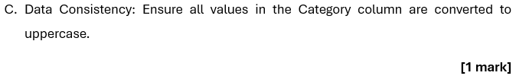
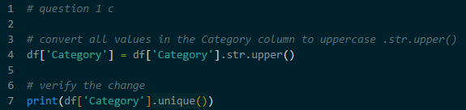
- Computers see Clothing and CLOTHING as two different things. To group them correctly, the text must look the same
- Action – Use .str.upper() on the Category column
- This changes all letters to uppercase. It ensures that when count categories later, the computer counts them together accurately

Question 1 D
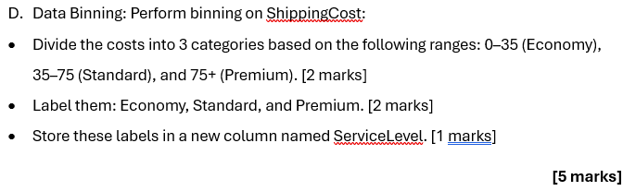
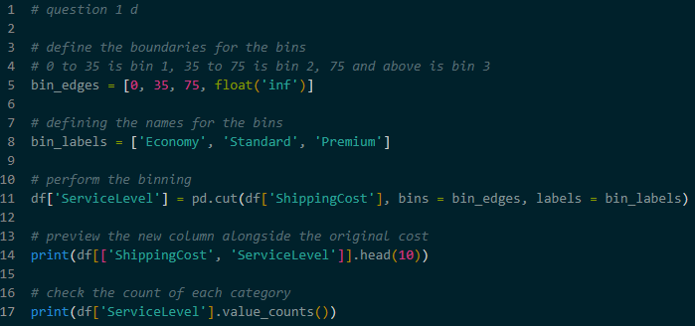
- Sometimes specific numbers (like $12.50) are more useful when labeled as a group
- Action – Use pd.cut(). Define edges (0, 35, 75 and infinity) and labels (Economy, Standard, Premium)
- This creates a new column called ServiceLevel. It helps to understand the data by looking at broad groups instead of individual prices

Question 1 E
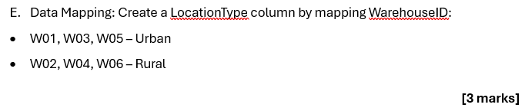
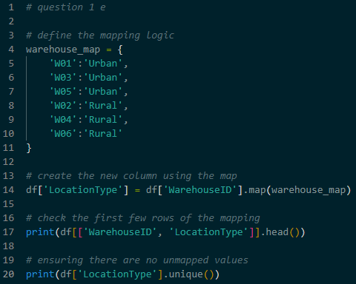
- Database often use short codes like W01 for space. For a report, it is better to use full words like Urban
- Action – Creating a Dictionary (a list of pairs) that links each WarehouseID to a LocationType. Using the .map() function
- This adds a new column that is easier for people to read and understand

Question 1 F
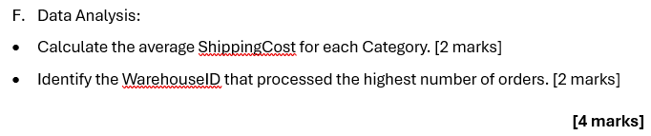
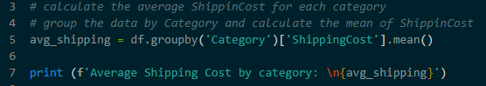
- To find the typical cost for a specific category, must be group all rows of that category together and find the mean
- Action – Use .groupby(). Select the Category to group by, select ShippingCost for the math, and use .mean()
- This tells which product category is the most or least expensive to ship on average

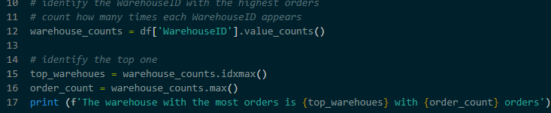
- To find out which warehouse is the busiest, need to count how many times each ID appears in the list
- Action – Use .value_counts(). This counts the rows for each warehouse. Use .idxmax() to find the name of the warehouse with the highest count
- This identifies the warehouse that processes the most orders

